**Assignment 1**-

Full_name --- First_name and Last_name

Salary --- Basic_Salary

HRA –10%

DA – 5%

PF – 7%

GrossSalary – Salary +HRA + DA – PF

1. select first_name,last_name,**concat**(first_name,last_name)as Full_name, salary,salary*.10 HRA ,salary*.5 DA, salary*.7 PF,**concat**(salary+salary*.10+salary*.5-salary*.7) as Gross_Salary from employees;
2. select first_name,last_name,concat(first_name,last_name)as Full_name, salary,salary*.10 HRA ,salary*.5 DA, round(salary*.7,2)as PF ,concat(salary+salary*.10+salary*.5-salary*.7) as Gross_Salary from employees;

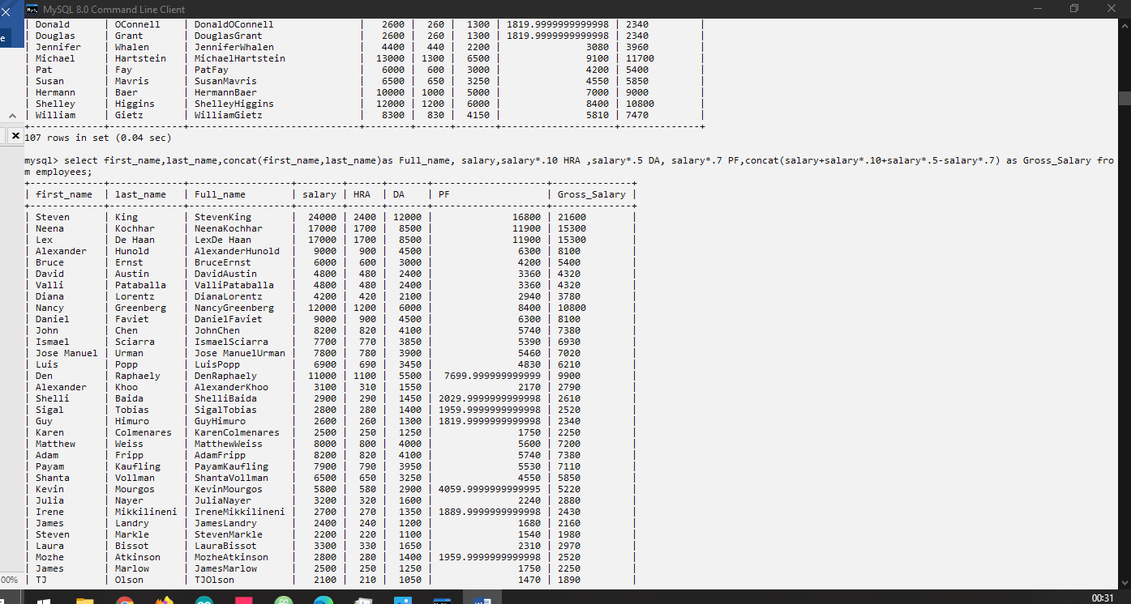

1)select * from employees where salary >10000;

1. select first_name,hire_date from employees where job_id ='IT_PROG' or job_id='SA_MAN';

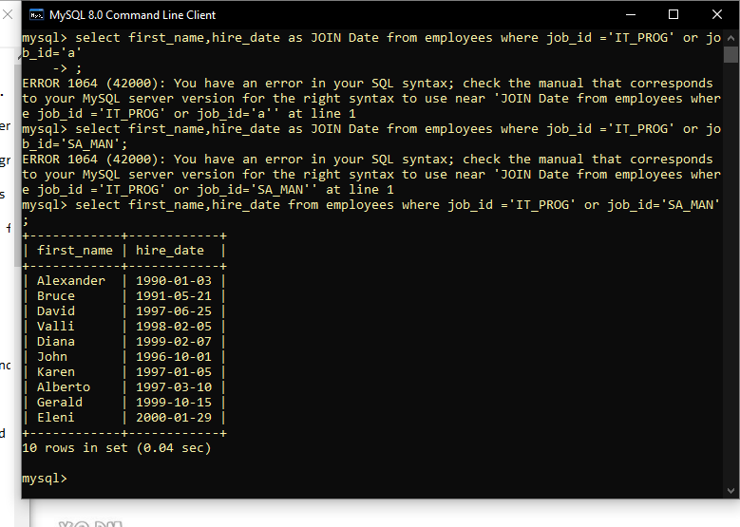

1. select first_name ,salary,commission_pct,hire_date from employees where salary < 10000;

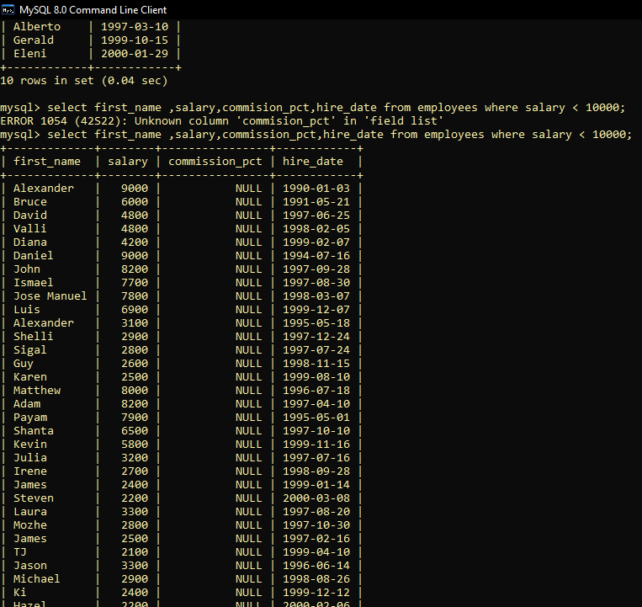

1. select first_name, last_name, hire_date from employees where year(hire_date) between 2002 and 2005 order by hire_date;
2. select * from employees where salary between 10000 and 20000 order by salary desc;

6) select * from employees where first_name or last_name like 'S%';

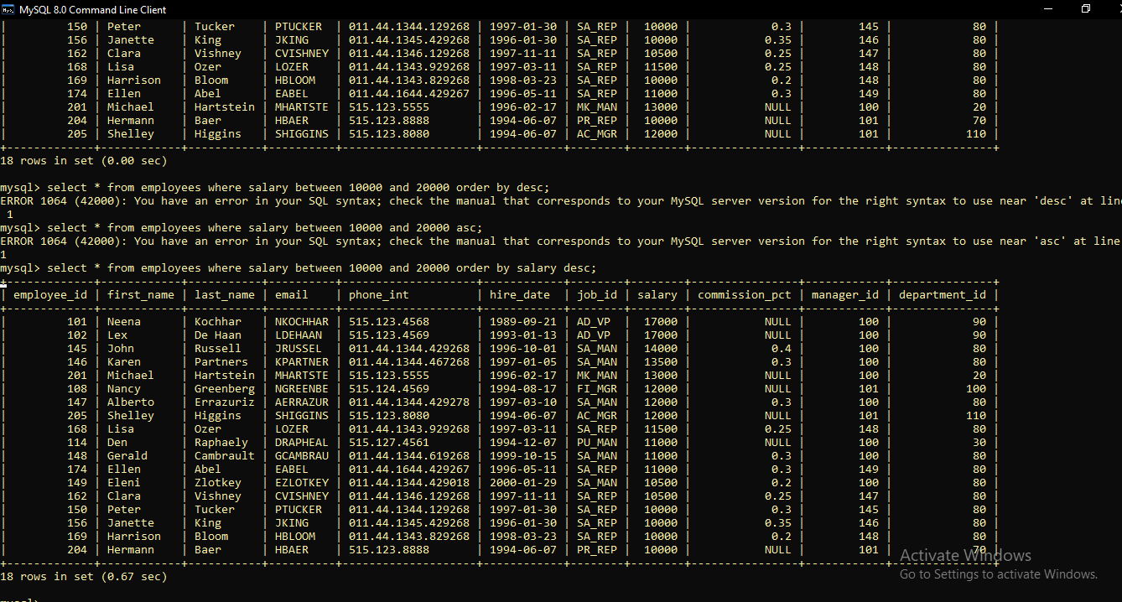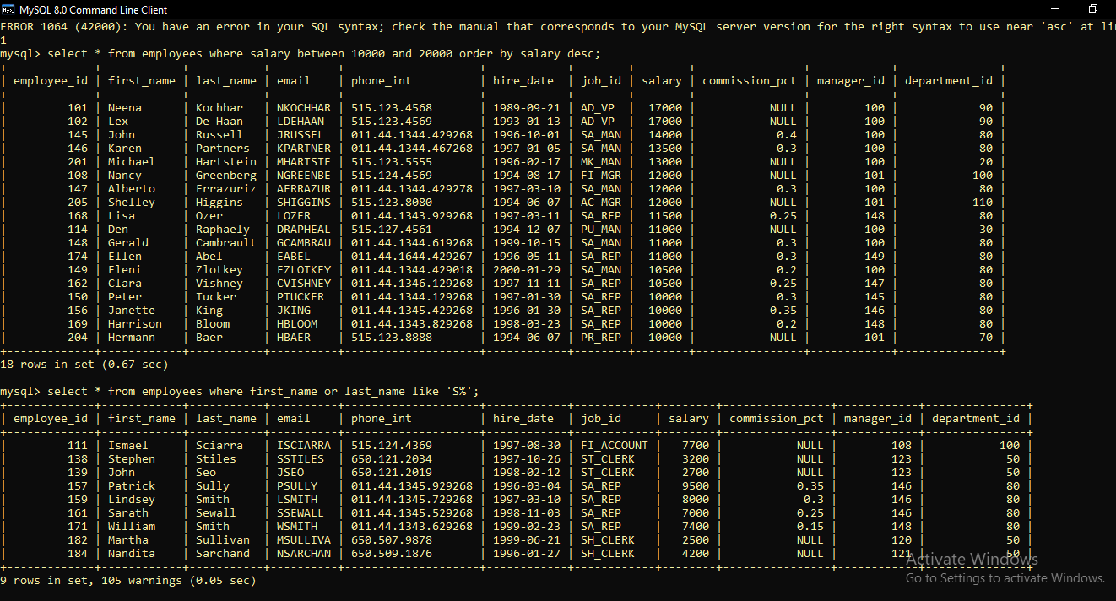

1. select job_id from employees order by job_id desc;

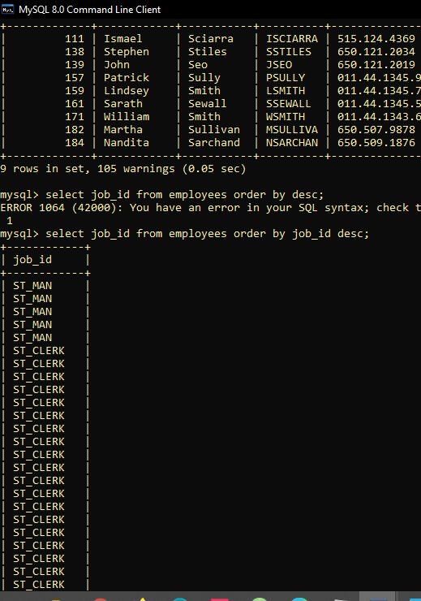

1. select employee_id, first_name,last_name,hire_date from employees where hire_date like '____-%05%-__';

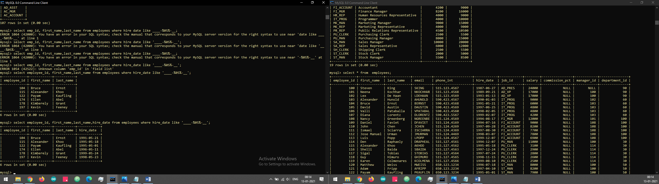

Display details of the employees where commission percentage is null and salary in the range 5000 to 10000 and department is 30.

select * from employees where commission_pct=null and salary between 5000 and 15000 and department_id=30 ;

**JOINS**

1. select employee_id, job_title, end_date-start_date Days from job_history natural join jobs where department_id=30;
2. select dept.department_id, dept.department_name, dept.manager_id, emp.first_name from departments dept inner join employees emp on (dept.manager_id = emp.employee_id);

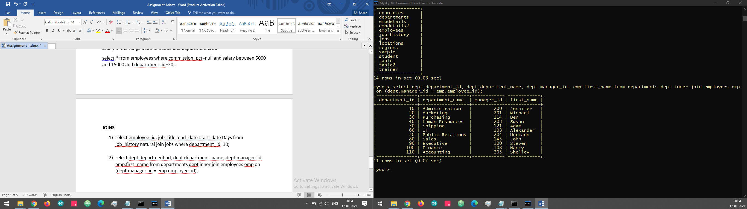

1. select dept.department_name,emp.first_name,l.city from departments dept join employees emp on (dept.manager_id=emp.employee_id) join locations l using(location_id);

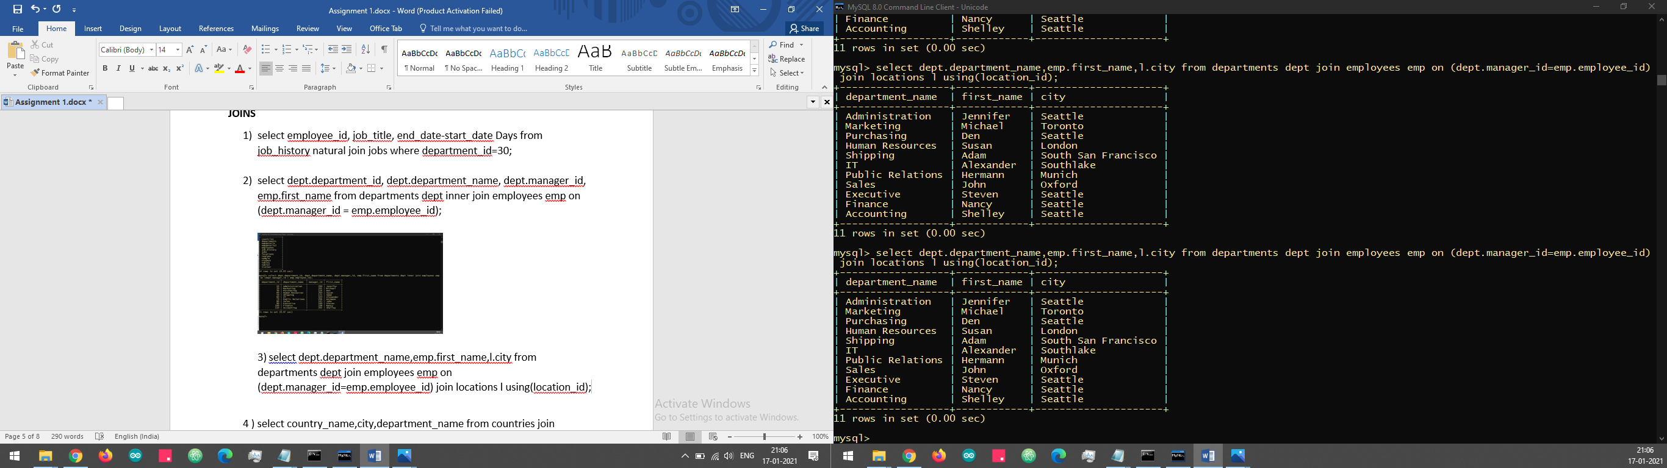

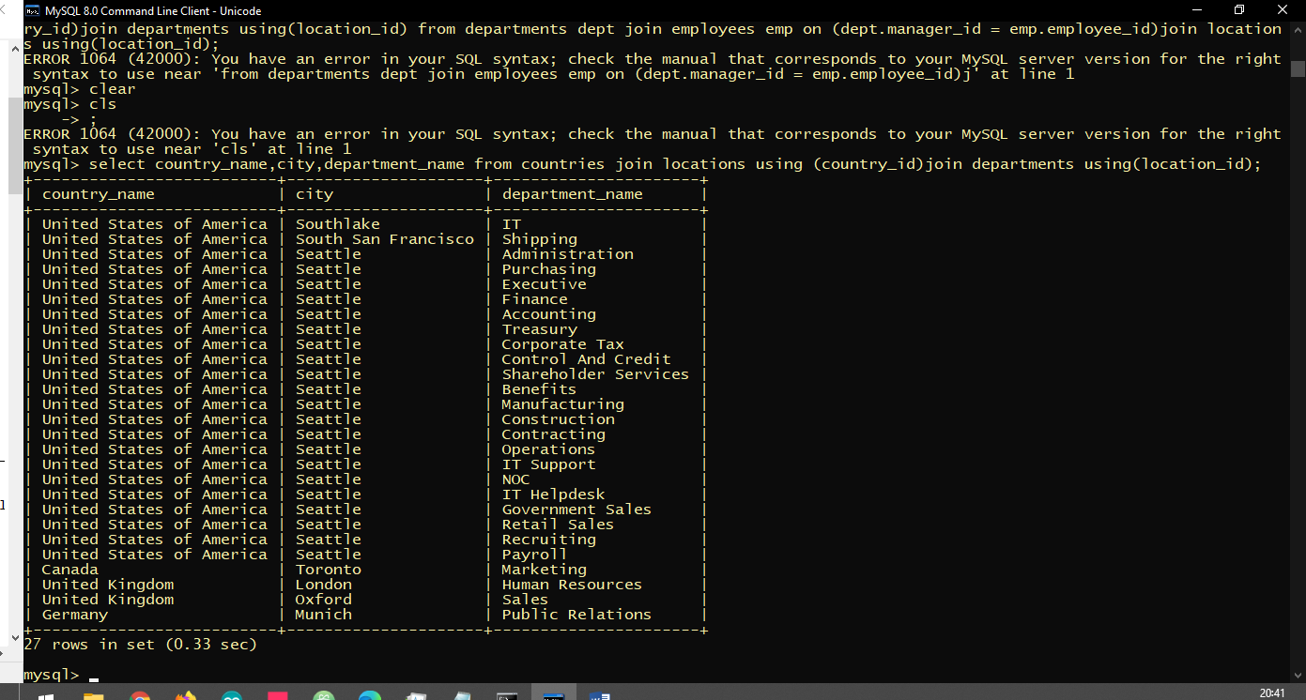4 ) select country_name,city,department_name from countries join locations using (country_id)join departments using(location_id);

5)select first_name, country_name from employees join departments using(department_id) join locations using(location_id)join countries using(country_id);



**Functions**

1. select first_name from employees where month(hire_date) like '5';

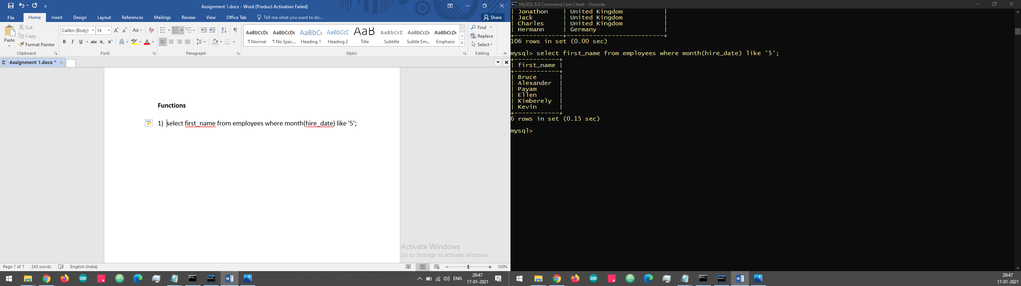

1. select first_name, salary,round(salary) as TotalSalary from employees;

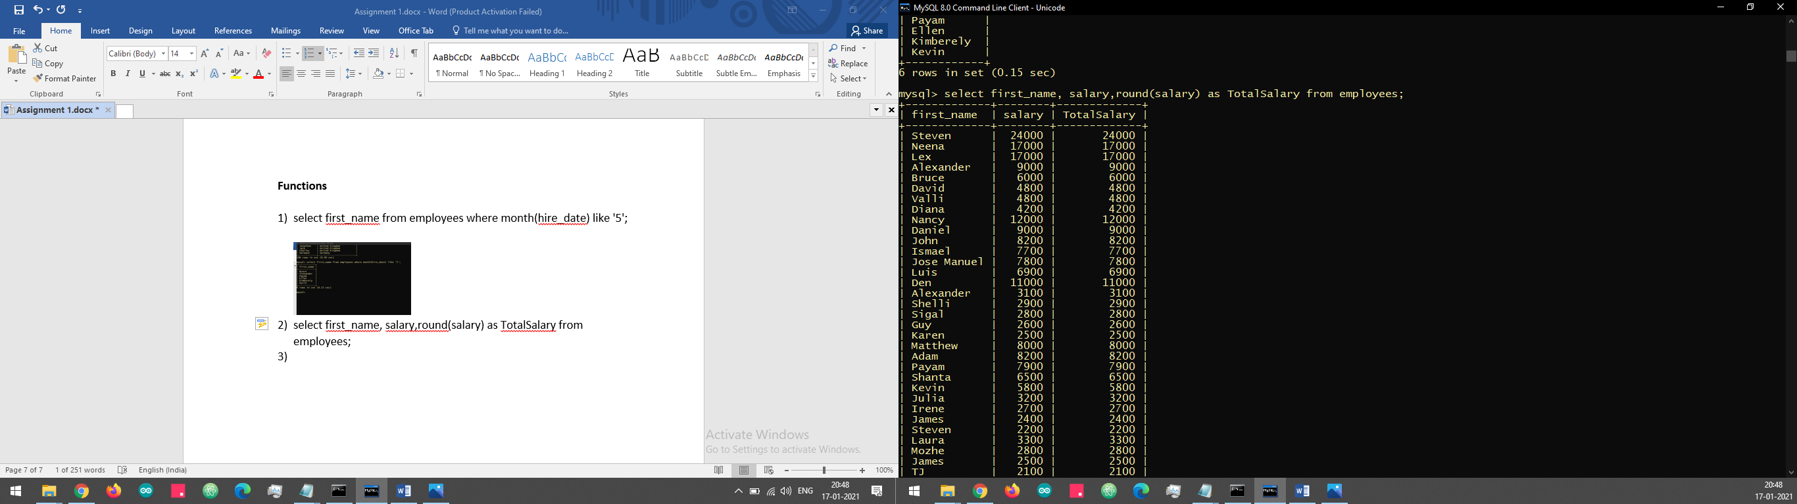

1. select first_name, last_day(hire_date)from employees;



1. select first_name, datediff(sysdate(),hire_date)/365 from employees;

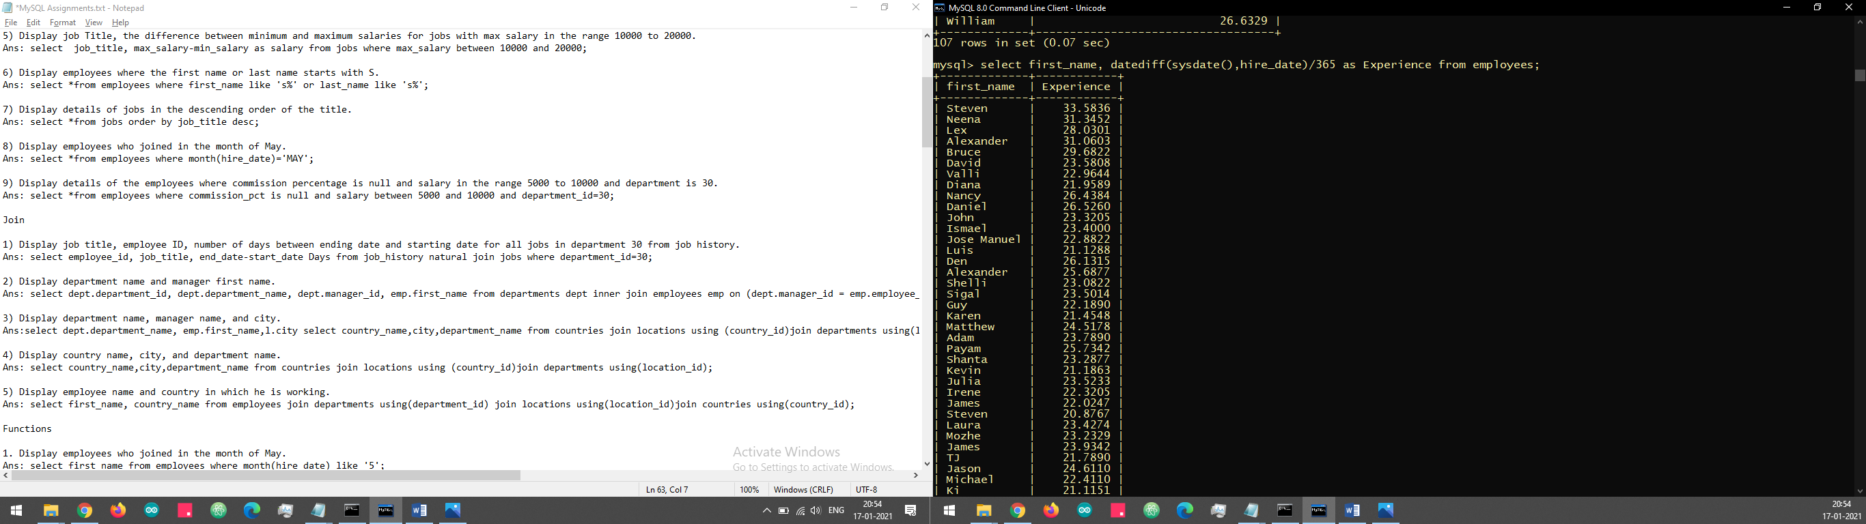

1. select first_name, country_name from employees join departments using(department_id) join locations using(location_id)join countries using(country_id);

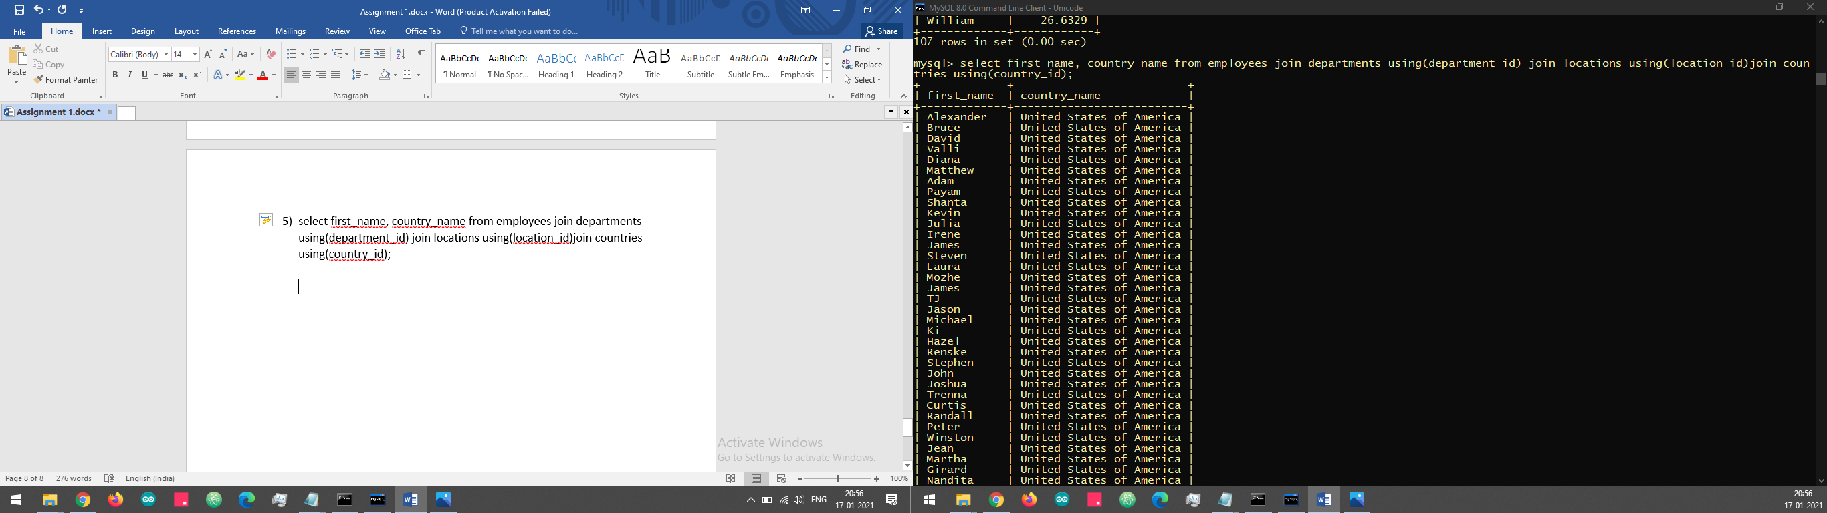

1. select upper(first_name), lower(email) from employees;

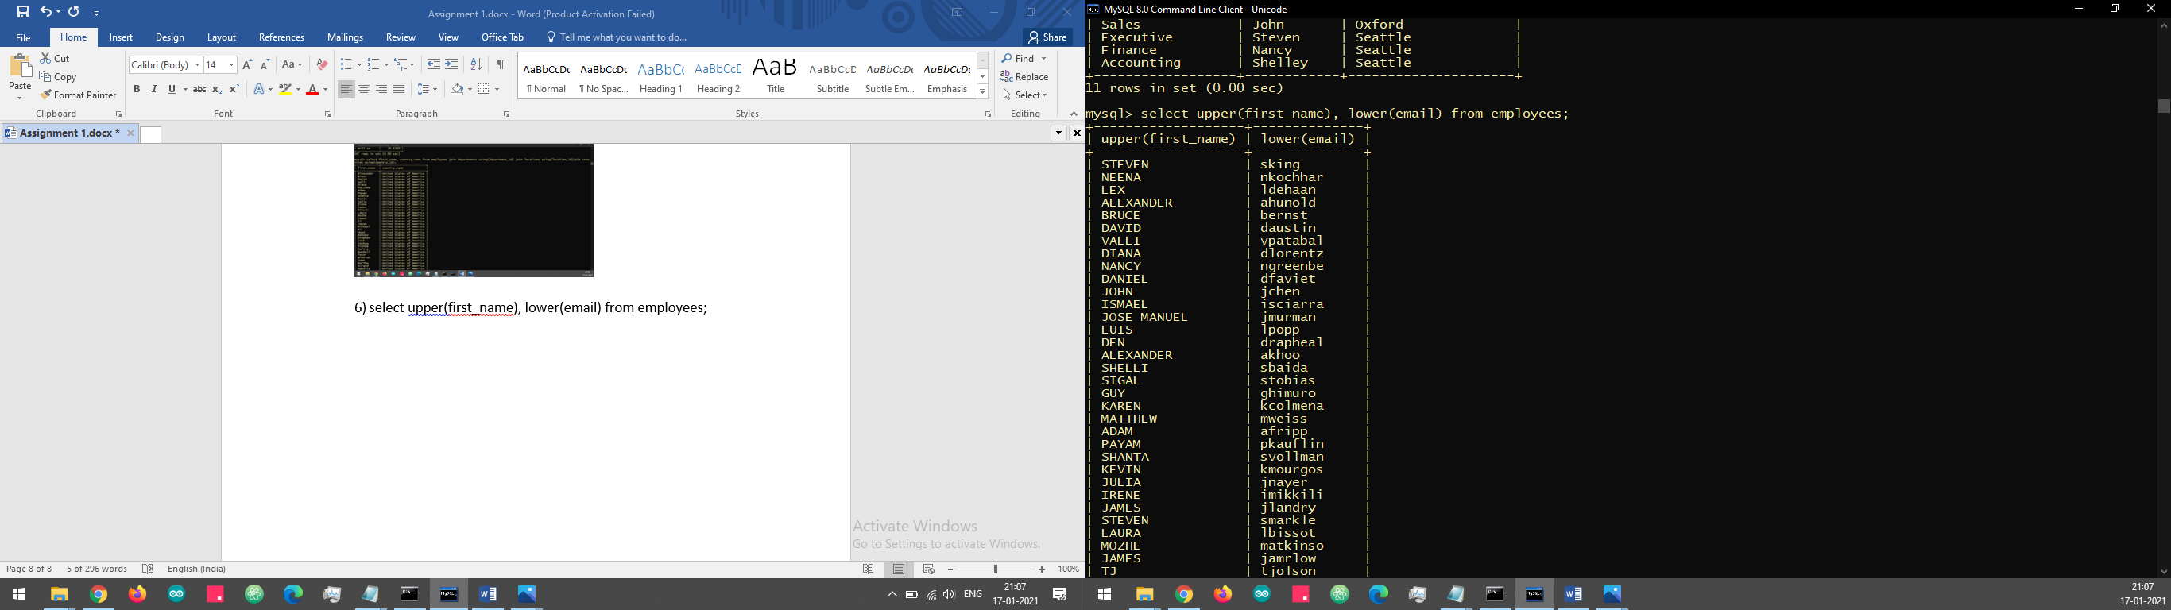

1. select *from employees where year(hire_date) = '2021';

8)

**Aggregate function**

1)select employee_id, max(end_date)from job_history where employee_id in(select employee_id from job_history group by 1 having count(employee_id)>1)group by 1;

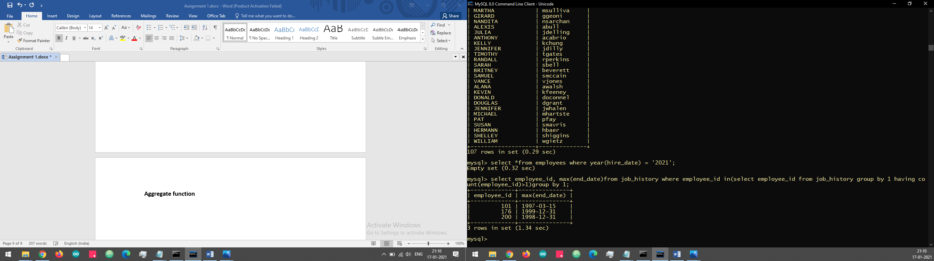

2) select count(employee_id) from employees where date(hire_date)>15;

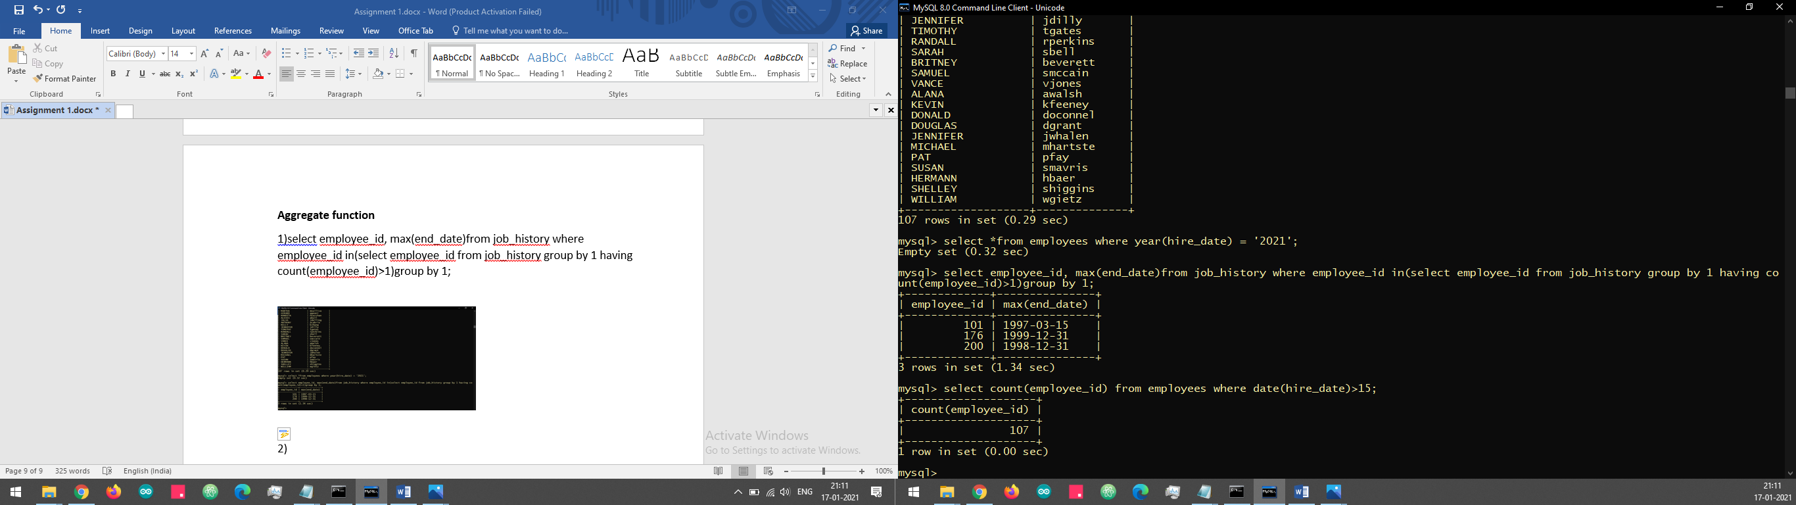

1. select country_id, count(*)from locations group by country_id;

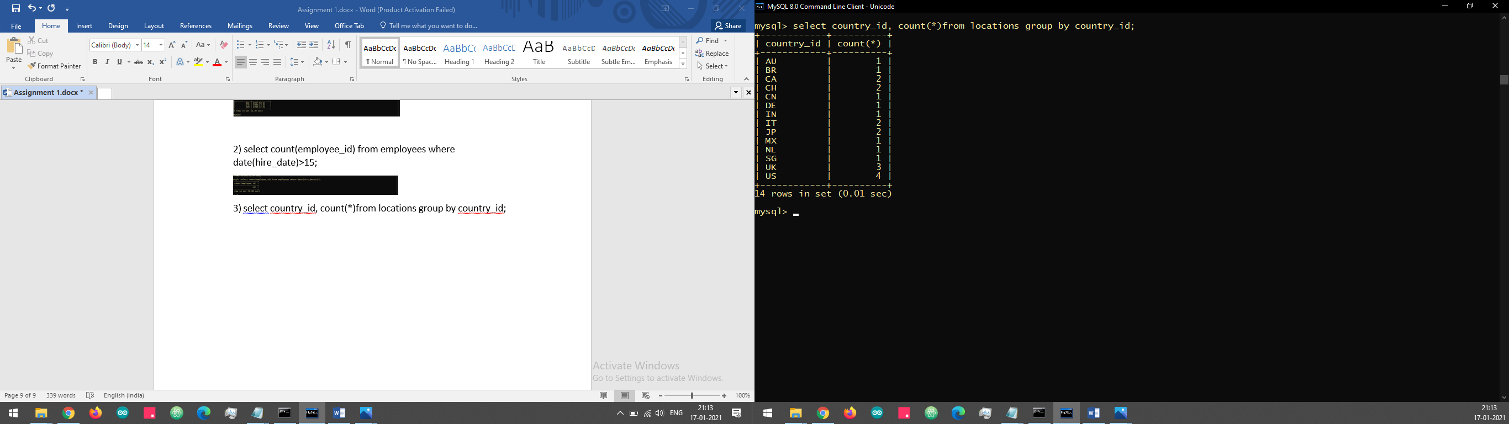

1. select department_id, avg(salary)from employees where commission_pct group by department_id;

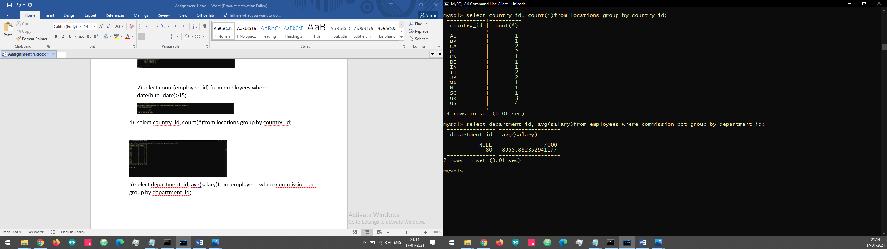

5) select employee_id, max(end_date)from job_history where employee_id in(select employee_id from job_history group by 1 having count(employee_id)>1)group by 1;

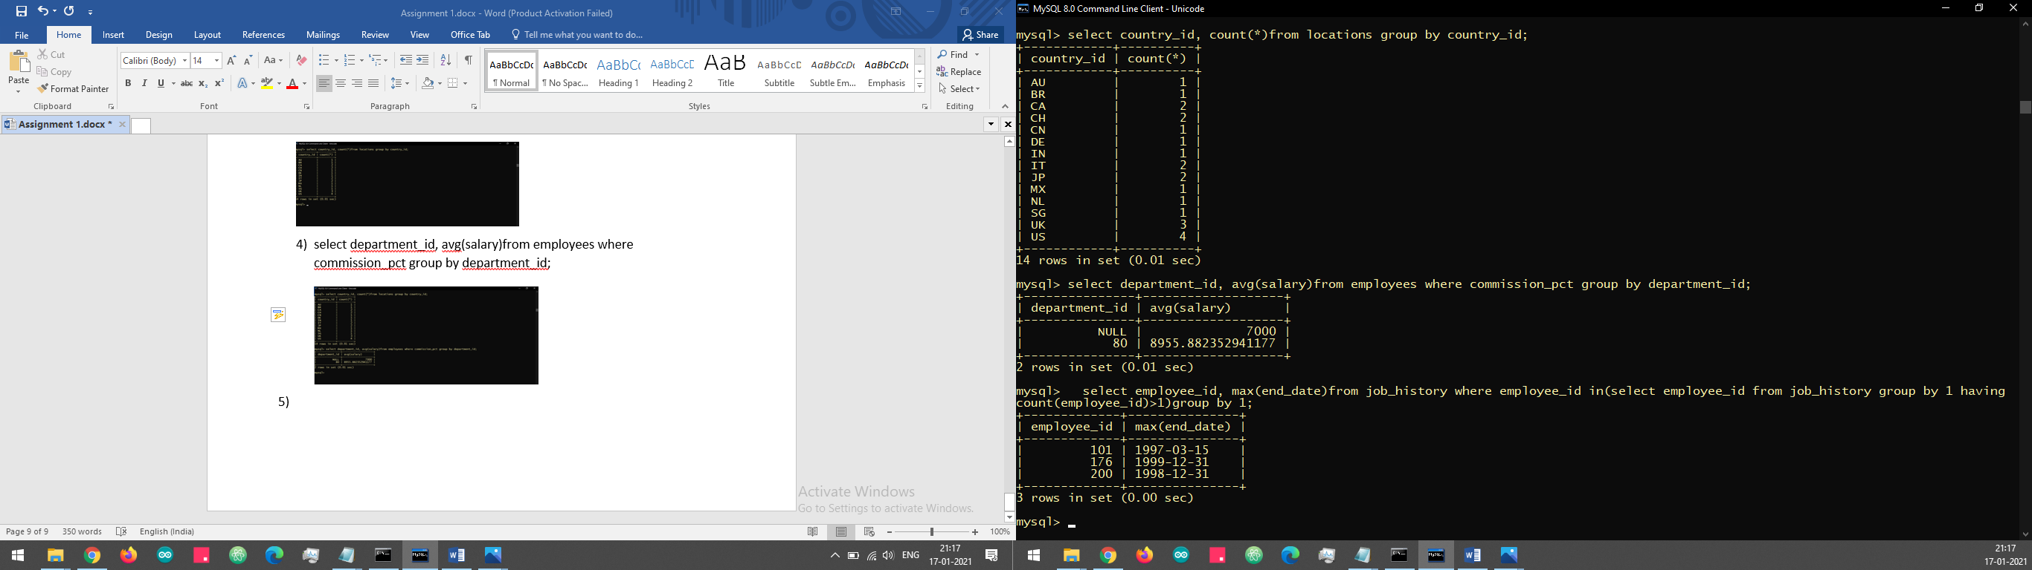

1. select job_id, avg(salary) from employees group by job_id having avg(salary)>10000;

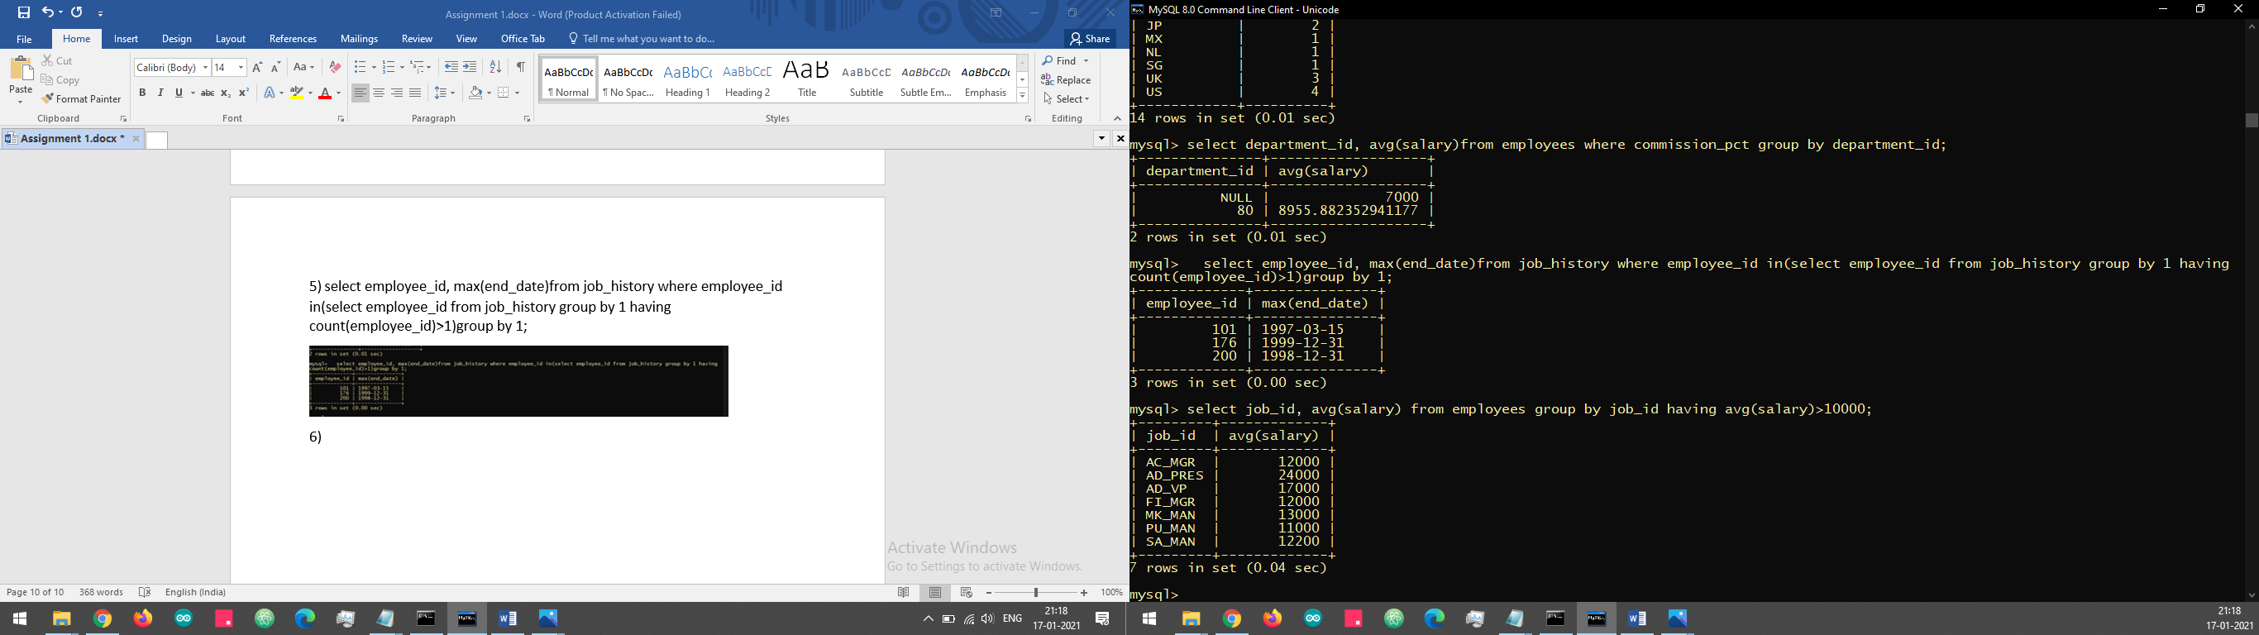

1. select date(hire_date)from employees group by date(hire_date) having count(employee_id)>10;
2. select department_id from employees where commission_pct group by department_id having count(commission_pct)>5;

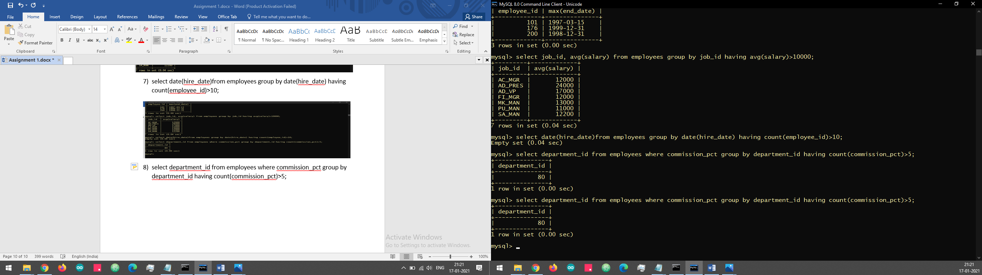

1. select department_name, count(*) from departments inner join employees on employees.department_id = departments.department_id group by departments.department_id,department_name order by department_name;

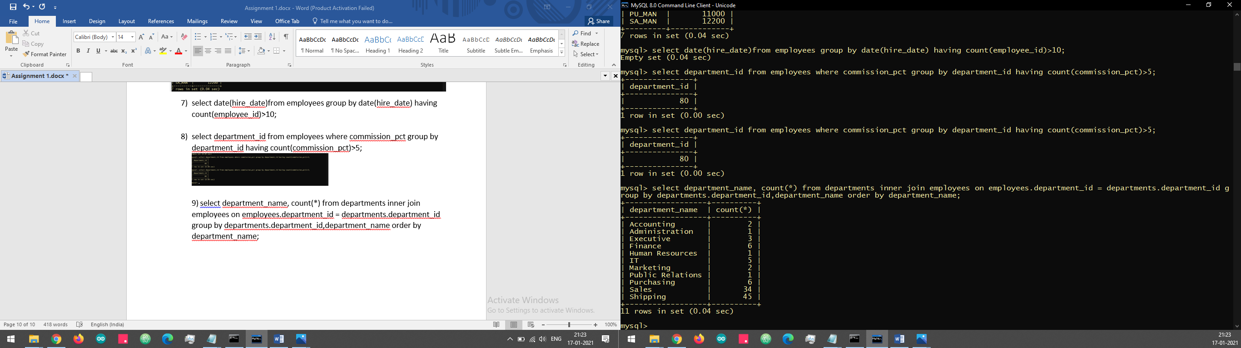

1. select employee_id from job_history group by employee_id having count(*)>=1;

